**Q1: Can you create a simple HTML navigation bar to navigate to a list of items with basic styling using CSS?**

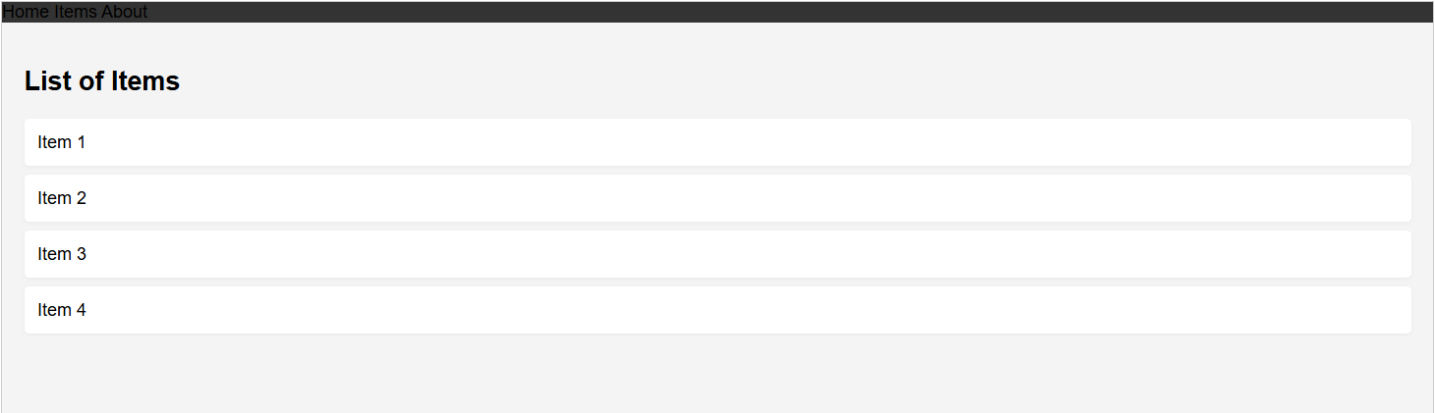

<!DOCTYPE html>

<html lang="en">

<head>

<meta charset="UTF-8">

<meta name="viewport" content="width=device-width, initial-scale=1.0">

<title>Simple Navigation Bar</title>

<style>

body {

font-family: Arial, sans-serif;

margin: 0;

padding: 0;

background: #f4f4f4;

}

.navbar {

background-color: #333;

overflow: hidden;

}

.navbar a {

float: left;

display: block;

color: #f2f2f2;

text-align: center;

padding: 14px 20px;

text-decoration: none;

transition: background 0.3s;

}

.navbar a:hover {

background-color: #575757;

}

.content {

padding: 20px;

}

ul.item-list {

list-style-type: none;

padding: 0;

}

ul.item-list li {

background: #fff;

margin: 8px 0;

padding: 12px;

border-radius: 4px;

box-shadow: 0 1px 3px rgba(0,0,0,0.05);

}

</style>

</head>

<body>

<div class="navbar">

<a href="#home">Home</a>

<a href="#items">Items</a>

<a href="#about">About</a>

</div>

<div class="content">

<h2 id="items">List of Items</h2>

<ul class="item-list">

<li>Item 1</li>

<li>Item 2</li>

<li>Item 3</li>

<li>Item 4</li>

</ul>

</div>

</body>

</html>

**Q2: Build an HTML navigation bar styled with CSS and include a JavaScript function to show or hide the options based on a user’s action (e.g., clicking a button).**

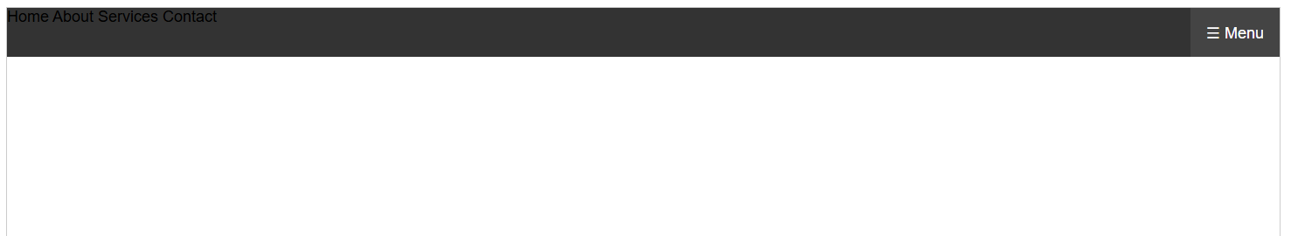

<!DOCTYPE html>

<html lang="en">

<head>

<meta charset="UTF-8">

<meta name="viewport" content="width=device-width, initial-scale=1.0">

<title>Navigation Bar Example</title>

<style>

body {

margin: 0;

font-family: Arial, sans-serif;

}

.navbar {

background-color: #333;

overflow: hidden;

}

.navbar a {

float: left;

display: block;

color: #f2f2f2;

text-align: center;

padding: 14px 16px;

text-decoration: none;

transition: background 0.3s;

}

.navbar a:hover {

background-color: #575757;

}

.toggle-btn {

float: right;

display: block;

background: #444;

color: #fff;

border: none;

padding: 14px 16px;

cursor: pointer;

font-size: 16px;

}

.nav-options {

display: flex;

}

@media (max-width: 600px) {

.nav-options {

display: none;

flex-direction: column;

width: 100%;

}

.navbar.responsive .nav-options {

display: flex;

}

.navbar a, .toggle-btn {

float: none;

width: 100%;

text-align: left;

}

}

</style>

</head>

<body>

<div class="navbar" id="navbar">

<button class="toggle-btn" onclick="toggleNav()">☰ Menu</button>

<div class="nav-options" id="navOptions">

<a href="#home">Home</a>

<a href="#about">About</a>

<a href="#services">Services</a>

<a href="#contact">Contact</a>

</div>

</div>

<script>

function toggleNav() {

var navbar = document.getElementById('navbar');

navbar.classList.toggle('responsive');

}

</script>

</body>

</html>

**Q3: Create a responsive HTML, CSS, and JavaScript interface that displays a navigation bar where certain options are visible only to a user with permission.**

**Información adicional: In one file.**

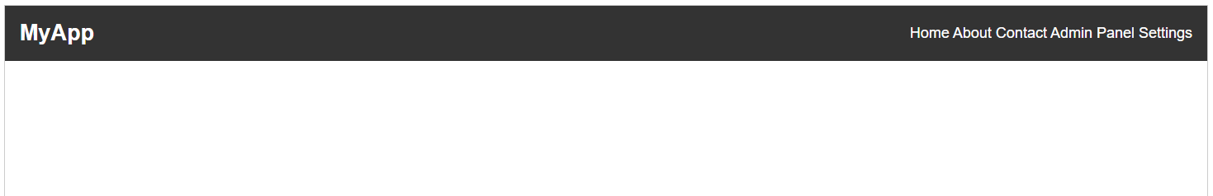

<!DOCTYPE html>

<html lang="en">

<head>

<meta charset="UTF-8">

<meta name="viewport" content="width=device-width, initial-scale=1.0">

<title>Responsive Navbar with Permissions</title>

<style>

body {

margin: 0;

font-family: Arial, sans-serif;

}

.navbar {

display: flex;

flex-wrap: wrap;

align-items: center;

background: #333;

color: #fff;

padding: 0 1rem;

}

.navbar-logo {

font-size: 1.5rem;

font-weight: bold;

padding: 1rem 0;

flex: 1;

}

.navbar-toggle {

display: none;

font-size: 1.5rem;

background: none;

border: none;

color: #fff;

cursor: pointer;

}

.navbar-links {

display: flex;

gap: 1rem;

}

.navbar-links a {

color: #fff;

text-decoration: none;

padding: 0.75rem 0.5rem;

border-radius: 4px;

transition: background 0.2s;

}

.navbar-links a:hover {

background: #444;

}

@media (max-width: 700px) {

.navbar {

flex-wrap: wrap;

}

.navbar-links {

flex-direction: column;

width: 100%;

display: none;

}

.navbar-links.open {

display: flex;

}

.navbar-toggle {

display: block;

}

}

</style>

</head>

<body>

<nav class="navbar">

<div class="navbar-logo">MyApp</div>

<button class="navbar-toggle" id="navbarToggle">☰</button>

<div class="navbar-links" id="navbarLinks">

<a href="#home">Home</a>

<a href="#about">About</a>

<a href="#contact">Contact</a>

<a href="#admin" class="permission-only" style="display:none;">Admin Panel</a>

<a href="#settings" class="permission-only" style="display:none;">Settings</a>

</div>

</nav>

<script>

// Simulate user permission (set to true or false)

const userHasPermission = true; // Change to false to test

// Show/hide permission-only links

document.querySelectorAll('.permission-only').forEach(link => {

link.style.display = userHasPermission ? '' : 'none';

});

// Responsive navbar toggle

const toggle = document.getElementById('navbarToggle');

const links = document.getElementById('navbarLinks');

toggle.addEventListener('click', () => {

links.classList.toggle('open');

});

// Optional: close menu when clicking a link (on mobile)

links.querySelectorAll('a').forEach(link => {

link.addEventListener('click', () => {

if (window.innerWidth <= 700) {

links.classList.remove('open');

}

});

});

</script>

</body>

</html>